* Any language, supporting a function call via a pointer, can be used to write COM components.
* **Virtual function tables:** COM has a standard way to put virtual function tables in memory which store function pointers.
* At runtime, functions are called through pointers in vtables.

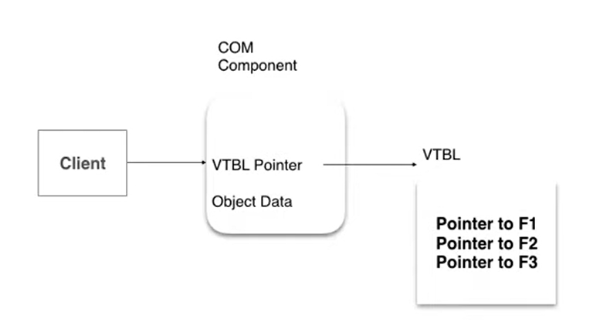

* COM components never have direct access to the object’s data. They can only interact through interfaces.
* **Interface:** A group of functions; not components or classes.
* **IUnknown interface:** Base interface implemented by all COM components. It provides functionality to query interface and adding and deleting references.
* **QueryInterface method:** Used by clients to request the interface available within COM component.
* **GUIDs:** A unique identifier assigned to every COM interface and class.
* GUID stands for Globally Unique IDs.
* These are 128-bit integers which are guaranteed to be unique across the universe.
* Microsoft provides a tool uuidgen.exe which generates GUIDs.
* **Reference Counting:** COM components are reference counted by AddRef and Release functions.
* **AddRef method:** Called when a COM component is using the interface.
* **Release method:** Called when a COM component no longer requires the use of the interface.
* A COM component remains in memory until the reference count is non-zero.
* A COM component unloads itself when the reference count becomes zero.
* **COM library:** Microsoft provides a COM library as part of the operating system.
* It facilitates loading and unloading of COM components.
* It facilitates connections between loaded components.
* It is a set of DLLs and EXEs.
* It provides mechanisms for creation of –
* COM components
* Remote Procedural Calls
* Memory management, etc
* When an application wants to use a COM component, the COM library uses Class IDs to look up for the COM component to be loaded (AddRef).
* The application then uses the COM component through the available interface.
* When the services of the COM component are no longer needed, the COM library unloads it (Release) from memory.